Homework 7 - Print out Solution

|  |  |  |
| --- | --- | --- |
| **Workshop 6** | **Answers** | **Answers** |
| **1a** | **-0.44970968** | **=+'Q2'!AC4** |
| **1b** | **0.11345343** | **=+'Q2'!AC4** |
| **1c** | **-0.26100166** | **=+'Q2'!AD5** |
| **2a** | **0.98995137** | **=+'Q2'!Z5** |
| **2b** | **-7567.07992** | **=+'Q2'!Z6** |
| **3a** | **0.00901662** | **=+'Q3'!AA4** |
| **3b** | **0.98859692** | **=+'Q3'!AA5** |
| **3c** | **-7546.7082** | **=+'Q3'!AA6** |
| **4a** | **0.02358793** | **=+'Q4'!AD6** |
| **4b** | **0.96464988** | **=+'Q4'!AD7** |
| **4c** | **1E-07** | **=+'Q4'!AD8** |
| **4d** | **-7508.98291** | **=+'Q4'!AD9** |
| **5a** | **0.0509676** | **=+'Q2'!AP2172** |
| **5b** | **0.0507706** | **=+'Q3'!AQ2172** |
| **5c** | **0.05130637** | **=+'Q4'!AU2175** |
| **5d** | **-0.04431399** | **=+'Q2'!AR2172** |
| **5e** | **11** | **=+'Q2'!AV4** |
| **5f** | **11** | **=+'Q3'!AW4** |
| **5g** | **13** | **=+'Q4'!BA4** |
| **6a** | **0.01737188** | **=+'Q5'!AJ2** |
| **6b** | **0.01441839** | **=+'Q5'!AE2** |
| **6c** | **0.17593042** | **=+'Q5'!AF14** |
| **6d** | **0.00929281** | **=+'Q5'!AB41** |
| **6e** | **2.16%** | **=+'Q5'!AB43** |
| **6f** | **-0.00449** | **=+'Q5'!L1153** |
| **6g** | **0.81229147** | **=+'Q5'!AC47** |
| **6h** | **-0.00314679** | **=+'Q5'!AB47** |
| **6i** | **0.904%** | **=+'Q5'!AD61** |
| **6j** | **0.906%** | **=+'Q5'!AD62** |
| **6k** | **0.896%** | **=+'Q5'!AD63** |
| **6l** | **40** | **=+'Q5'!AD63** |
| **6m** | **40** | **=+'Q5'!AE62** |
| **6n** | **40** | **=+'Q5'!AE63** |

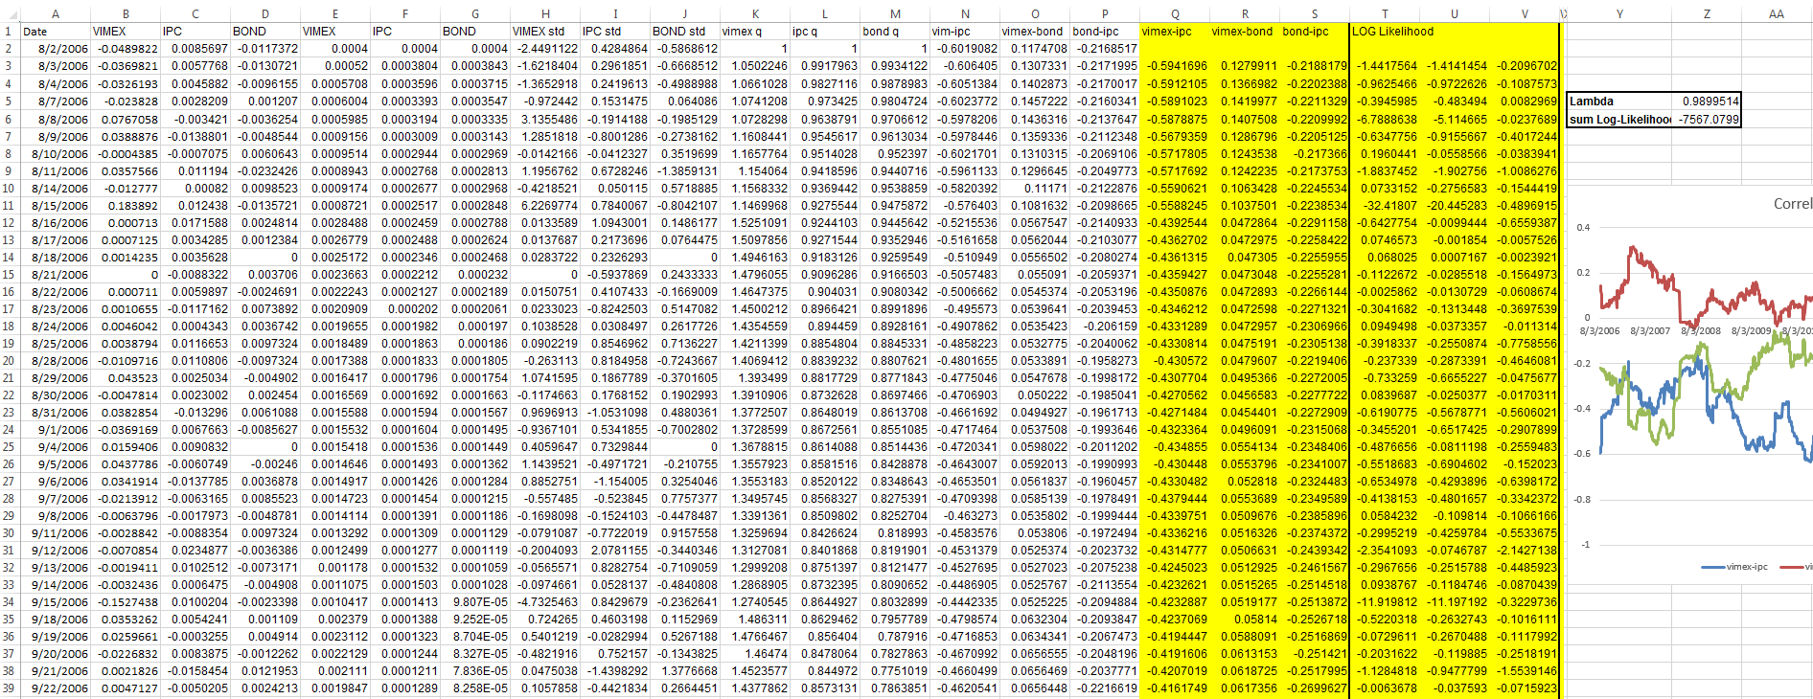Question 1-2 (Q2)

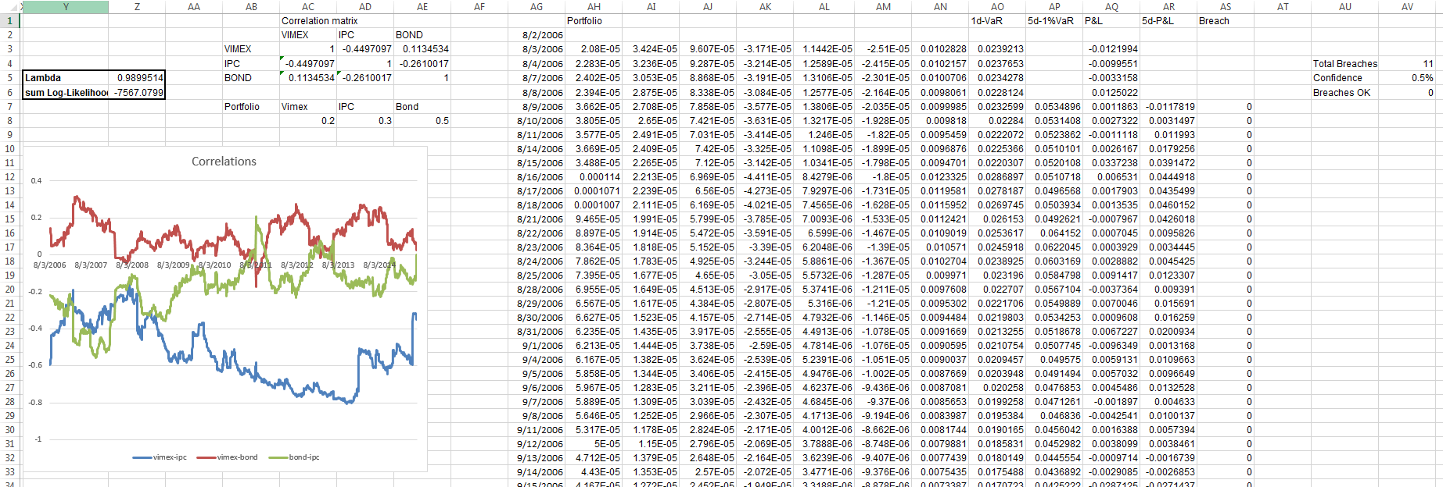

Q3

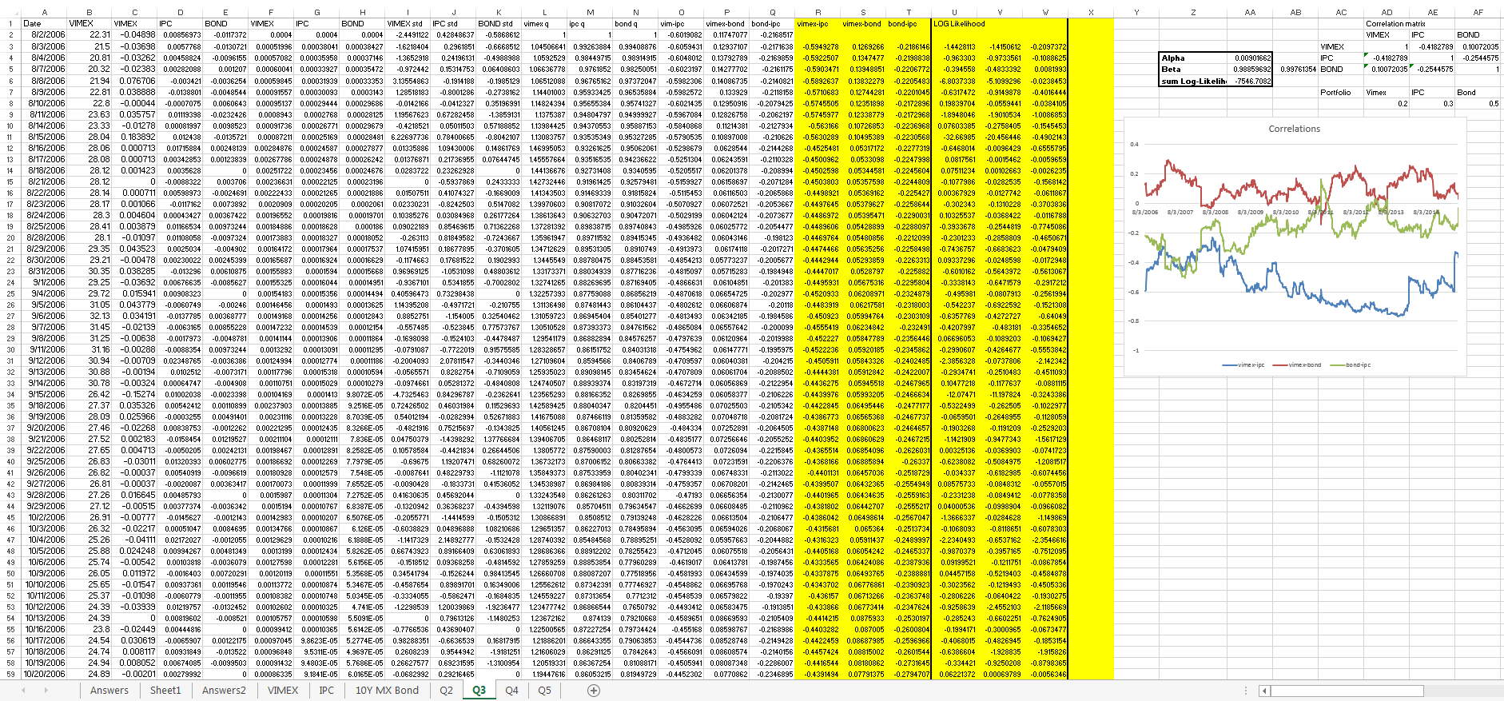

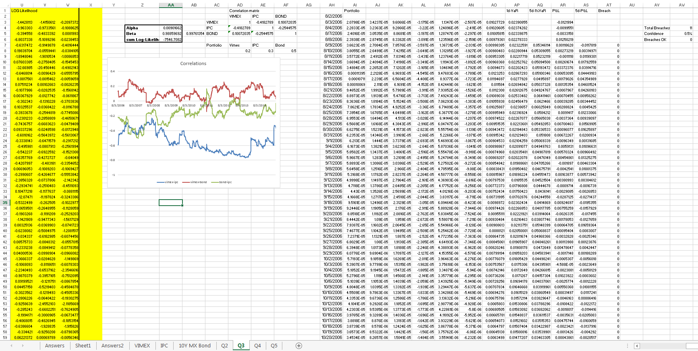

Q4

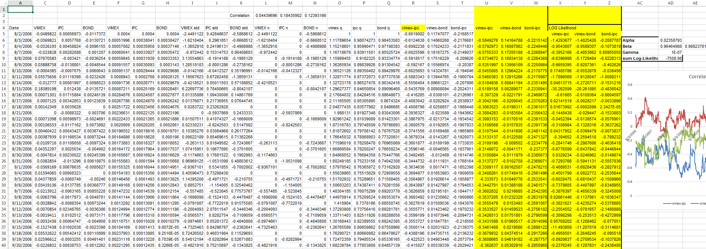 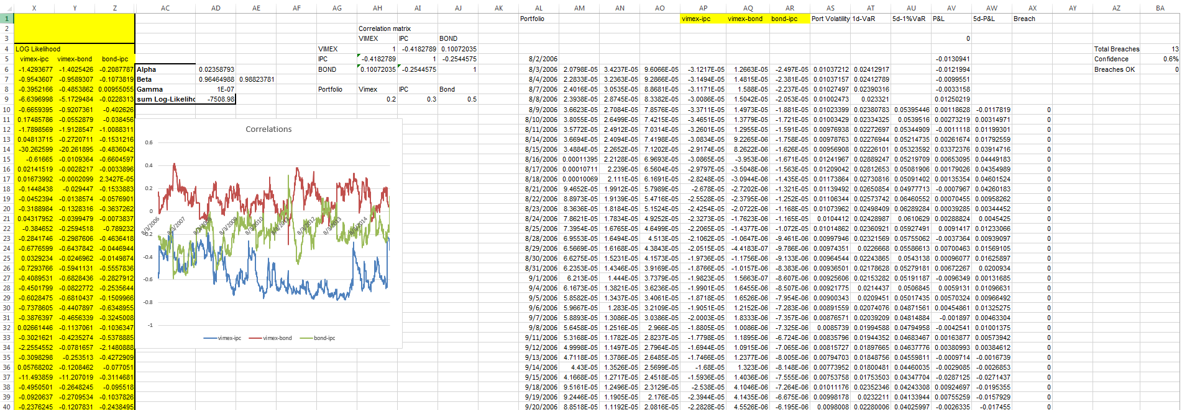

Q5

